

**COLLEGE OF BUSINESS AND ECONOMICS SCHOOL OF BUSINESS AND ECONOMICS DEPARTMENT OF BUSINESS TECHNOLOGY**

**LEVEL 2, GROUP 1**

**COURSES**

Party 1. SYSTEM ENGINEERING

Party 2. DATABASE MANAGEMENT SYSTEM

Party 3. JAVA PROGRAMMING

CODE: BIT 2131 PROJECT PROPOSAL ON

**Project Name:**

**ADVANCED DRIVER MANAGEMENT SYSTEM**

**Student name: KWIZERA Valentin**

**Reg No: 222007317**

**Submitted to: Dr. BUGINGO Emmanuel**

**Date: 08March 2024**

Party 1. SYSTEM ENGINEERING

# Table of contents

Table of Contents

Table of contents 3

List of Figures 5

List of tables 5

1. Introduction 6

1. Statement of the problem 9

2.1 Description of the existing system 9

2.2 Problems of the current system 9

2.3 How the proposed system will work 11

1.4 Describe other alternatives 12

2. Software requirement 13

3.1 User Requirements 13

3.1.1 Functional requirement 13

3.1.2 Non-function requirement 14

Portability requirement 14

Reliability requirement 16

Usability requirement 17

Space requirement 18

Organization requirement 20

Implementation requirement 20

External environment requirement 21

Privacy requirement 21

Safety requirement 23

3.2 System requirements 24

3.2.1 Minimum End-user Hardware Requirements 24

3.2.2 Minimum End-user Software Requirements 24

3.3 Software specifications 25

**4** DATA FLOW DIAGRAM (LEVEL 0, LEVEL 1**)** 27

4.1 DFD LEVEL 0 27

4.2 DFD LEVEL 1 27

5. Feasibility study 28

5.1 Technical Feasibility 28

5.2 Financial Feasibility 29

5.3 Market Feasibility 31

5.4 Economic Feasibility 32

5.5 Legal and Regulatory Feasibility 33

5.6 Operational Feasibility 34

6. Description of the selected Process Model 35

6.1 Cause of your selection 35

7. Conclusion 36

8. References 38

# List of Figures

Figure 1 DFD Level 0 19

Figure 2 DFD Level 1 20

# List of tables

Table 1. Key Features of advanced driver system 9

Table 2. The minimum end-user hardware requirements for accessing and utilizing the advanced driver System: 23

Table 3. The minimum end-user software requirements for accessing and utilizing the advanced driver System: 23

# 1. Introduction

Advanced driver system is modern system that will gives reliable drivers to someone who need them. This system will have used technology material and has the purpose of giving the drivers to someone for easy. This system will help people who are not able to drive their own car because of different reasons.

After seeing issue of lose a driver for someone who drunk and other who are tired, whom not be able to drive, and it is very difficult to find drivers who can be driven them because they have not information of where they can find them.

The system will be completed when the user shall login in other can have access to the system but before he/she should be registered in order he/she might be a user. So, after login the system shall show him/her more information about the driver and then can request a service.

The system will help a professional driver to be employed because they can sign a contract of being employee of this system, the client could be driven with trusted drivers. Improved travel planning: Travelers can use z to plan their trips more efficiently. This can save time and money, and it can also help to reduce stress of lose a driver.

In this system we faced with challenge of someone who are conservatism, where they are not understood the new system which can help them. High cost of internet where some people are not online every time, and some people have not basic skills about using technology and they have not trust online services.

This will be implemented in Rwanda because we have GERAYO AMAHORO Politic which have the purpose of decrease accident which caused by drunk drivers and other which caused by tiredness of drivers.

The system has purpose to satisfy the user what they deserve to be served where the user can obtain driver in all part of country. And protection of privacy of user is responsibility.

**The objective of advanced driver system project**

The objective of advanced driver system project is to create a system that is customer-centric and focused on delivering high-quality services. This can be achieved by:

**Understanding the needs of the customer**. The first step is to understand what the customer wants and needs from the service. This can be done through surveys, interviews, and focus groups.

**Designing a system that is easy to use and navigate**. The system should be designed in a way that is easy for customers to use and understand. This includes using clear language, providing clear instructions, and offering help and support when needed.

**Delivering high-quality services**. The system should be able to deliver high-quality services that meet the customer's expectations. This includes providing accurate information, resolving problems quickly, and being responsive to customer requests.

**Integration**: Ensuring seamless integration with existing systems and third-party applications to facilitate smooth adoption by service providers and users alike.

**Measuring and improving the system.** The system should be regularly measured and improved to ensure that it is meeting the customer's needs. This can be done by collecting feedback from customers, tracking performance metrics, and making changes to the system as needed.

**Enhance customer experience**: The project aims to improve the overall customer experience by providing prompt, reliable, and personalized services. This can involve streamlining service delivery processes, implementing self-service options, and optimizing response times.

**Increase operational efficiency**: The project aims to optimize service operations, minimize manual intervention, and automate repetitive tasks. This can lead to increased efficiency, reduced costs, and improved productivity.

**Improve service quality:** The project aims to establish standardized service processes and procedures to ensure consistent quality across all interactions. This may involve implementing quality control measures, training staff, and setting up performance metrics to monitor service delivery.

**Enable scalability and flexibility:** The project aims to design a system that can scale with increasing demand and adapt to changing customer needs. This can involve implementing a flexible architecture, leveraging cloud-based technologies, and incorporating scalability features to accommodate growth.

**Enable data-driven decision-making:** The project aims to collect and analyze data related to service delivery, customer interactions, and operational metrics. This data can be used to gain insights, identify areas for improvement, and make informed decisions to enhance service performance.

**Real-Time Tracking:** Users will be able to track the status of their service requests in real-time, providing them with transparency and peace of mind.

**Strengthen communication and collaboration**: The project aims to facilitate effective communication and collaboration between various stakeholders, including customers, service agents, and management. This can involve implementing communication channels, integrating systems, and providing real-time updates on service requests.

Overall, the objective of advanced driver system project is to create an integrated and efficient system that optimizes service delivery, enhances customer satisfaction, and drives organizational growth.

Table 1. **Key Features of advanced driver system**

|  |  |
| --- | --- |
| **Features** | **Description** |
| Real-Time Tracking | Users will be able to track the status of their service requests in real-time, providing them with transparency and peace of mind. |
| Smart Resource Allocation | Employing predictive analytics to allocate resources efficiently, minimizing idle time and maximizing service provider productivity. |
| Intelligent Recommendations | Utilizing machine learning algorithms to offer personalized service recommendations based on user history and preferences. |
| Feedback Mechanisms | Implementing feedback loops to gather user insights, enabling continuous improvement of service quality. |
| Loose coupling | The services in advanced driver system are loosely coupled, which means that they are not tightly integrated with each other. This makes the system more flexible and adaptable, and it also makes it easier to maintain and evolve the system. |
| Reusability | The services in advanced driver system are designed to be reusable, which means that they can be used in different applications. This can save time and effort, and it can also help to ensure that the system is consistent and reliable. |
| Fault tolerance | Advanced driver systems are fault tolerant, which means that they can continue to operate even if some of the services fail. This is because the services are loosely coupled, so the failure of one service does not affect the other services. |
| Scalability | Advanced driver systems are scalable, which means that they can be easily scaled up or down to meet the needs of the application. This is because the services are independently developed and deployed, so they can be scaled independently. |
| Data-driven decision making | Advanced driver systems use data and analytics to make decisions about how to deliver services. This data can come from a variety of sources, such as customer interactions, operational data, and environmental data. |

# Statement of the problem

## 2.1 Description of the existing system

In existing system, the people can be driven with drivers who has not had more information about him/her and who are not trusted. And other people can drive when they are drunk alcohol, where police can give them punishment such as imprisonment of one week and park a car for 21days.

The people can be connected with drivers and another platform where they can find them. When personal have health issue, it can be an obstacle of his/her travel because it not eases to obtain a reliable driver.

When the people may not drive their car because of have different issues, they can take motorcycle or taxi car. Now we have GERAYO AMAHORO politic, where people can drive when they have fresh health and mind in order to decrease accident which can caused by to be tired and drunk. In existing system, the people who are not able to drive have challenge getting driver.

One of the main problems with the current system is the lack of standardization. There is no single standard for advanced driver, which can make it difficult to integrate different systems and services. This can lead to inefficiency and duplication of effort.

Another problem with the current system is the security risks. Advanced driver can be vulnerable to security risks, such as unauthorized access, data breaches, and denial-of-service attacks. This is because advanced driver often relies on the sharing of data between different organizations, which can make it difficult to protect sensitive data.

The current system can be complex to manage and comply with regulations. Advanced driver can be complex to manage, and they often need to comply with a variety of regulations, such as those related to data privacy and security. This can be a challenge for organizations, especially small businesses and organizations that do not have the resources to dedicate to compliance.

## 2.2 Problems of the current system

**Inefficiency**: The lack of standardization can make it difficult to integrate different systems and services, which can lead to inefficiency and duplication of effort.

**Security breaches**: Advanced driver can be vulnerable to security breaches, which can lead to the loss of sensitive data.

**Compliance issues**: Advanced driver can be complex to manage and comply with regulations, which can lead to fines and penalties.

**Cost:** Advanced driver can be expensive to implement and maintain, which can put a strain on resources.

**Lack of transparency**: The lack of transparency in the algorithms used by ride-hailing platforms is a major concern. Client often has limited visibility into factors that determine pricing, such as surge pricing or route selection. This lack of transparency can lead to distrust and frustration among users.

The people do not trust the security of their car because they have not enough information about their drivers.

**Lack of communication**: There is often a lack of communication between the different stakeholders involved in the current system, such as the users, the technical experts, and the business managers.

**Driver working conditions**: Many drivers for ride-hailing services are classified as independent contractors, which means they may not receive benefits or protections typically provided to employees. This can lead to issues such as long working hours, low wages, and lack of job security.

**Lack of skills:** There is a lack of skilled professionals who are able to design, implement, and manage driven services.

**Change management**: Advanced driver can require significant changes to the way that organizations operate, which can be difficult to manage.

**Culture:** Advanced driver can require a change in culture, as organizations need to be more open to sharing data and collaborating with other organizations.

And also, other some problems are:

The people can lose communication with reliable drivers.

When someone who drunk can lose a driver who can drive him/her.

Driver can have health issue where it can be difficult to obtain other drive.

Some driver has not integrity, where he/she can have bad behavior in their job.

Some people buy car without driving license but they have problem of obtain a reliable driver.

Unemployment caused by shortage information of drivers.

Waste of time, when the people wait a driver.

## 2.3 How the proposed system will work

Advance driver system, it will work for giving drivers to someone who need them.

This system should start to the registration of drivers to the admin, the second step is registration of client this shall have access to the third step of checking more information about drivers here a client could see a detail of drivers.

The fourth step is where a client can request services in a system and after request it, h/she can receive feedback for few moments. Then a driver can be dispatched /sent to the client.

When a driver arrives to the client, she/he can be driven him/her from one place to anywhere their want.

In this system after getting services of client, he/she will receive a bill of payment from accountant and then can making payment. Driver and accountant will receive a notification of payment.

And also, the proposed system of driven services will work in a number of ways. First, there will be a single standard for advanced driver. This will make it easier for organizations to integrate different systems and services, and to comply with regulations.

Second, there will be a focus on security. Advanced driver will be designed and implemented with security in mind. This includes using strong authentication, encryption, and access control measures.

Third, there will be a focus on compliance. Advanced driver will be managed in accordance with relevant regulations. This includes having a comprehensive compliance program in place.

Fourth, there will be a focus on cost-effectiveness. Advanced driver will be implemented and maintained in a cost-effective manner. This includes using cloud-based solutions and open-source software.

The proposed system of advanced driver will have a number of benefits for organizations. These benefits include:

Increased efficiency: advanced driver can help organizations to improve efficiency by automating tasks and by sharing data between different organizations.

Improved collaboration: advanced driver can help organizations to improve collaboration by providing a platform for sharing data and for working together on projects.

Enhanced customer service: advanced driver can help organizations to enhance customer service by providing a platform for providing real-time customer support and by personalizing the customer experience.

Driver Empowerment and Benefits: The proposed system would prioritize driver well-being and offer those improved working conditions and benefits. This could include fair compensation, flexible working hours, access to benefits like insurance and retirement plans, and opportunities for skills development and career growth.

## Describe other alternatives

In other alternatives, advanced driver system is information system product which is easy useful and using cashless, where the client can pay using mobile money, easy cash, e banking etc.

The system has profession drivers and can get a notification of process to the client.

Time management and working on time is unique of this system, other unique is having drivers whom are cleanliness, discipline and security where client driven can feel safety.

Process in advanced driver system: In this alternative, the focus is on managing and optimizing the underlying processes involved in service delivery. The system would include features like process modeling, workflow automation, task assignment, and performance monitoring to streamline service delivery and improve efficiency.

Customer of advanced driver system: This alternative place a strong emphasis on customer engagement and satisfaction. The system would include features such as personalized customer profiles, customer feedback management, loyalty programs, and targeted marketing campaigns to enhance the customer experience and build long-term relationships.

Data in advanced driver system: This alternative emphasizes the collection, analysis, and utilization of data to drive decision-making and service improvements. The system would include advanced analytics capabilities, data visualization, predictive modeling, and machine learning algorithms to identify trends, optimize resource allocation, and deliver personalized services.

Mobile of advanced driver system: With the increasing use of mobile devices, this alternative focuses on providing a mobile-centric experience for both service providers and customers. The system would include features like mobile apps, location-based services, push notifications, and mobile payment integration to enable seamless service delivery and enhance convenience.

Integration of advanced driver system: This alternative emphasizes the integration of various systems and platforms to provide a unified experience for service providers and customers. The system would include features like API integration, data synchronization, and interoperability with external systems to ensure smooth information flow and collaboration across different channels.

Knowledge within advanced driver system: In this alternative, the system focuses on capturing, organizing, and leveraging knowledge to support service delivery. The system would include features like a knowledge base, expert systems, chatbots, and self-service portals to provide quick access to information, troubleshoot common issues, and empower users with self-help resources.

## Software requirement

## 3.1 User Requirements

### 3.1.1 Functional requirement

User can obtain all detail of driver

System can connect user with driver

**User can get comment about services or Ratings and Reviews:** Users should be able to rate and provide feedback on the services received, helping future users make informed decisions.

**User can make payment processing:** The system should support secure online payment processing, allowing users to pay for services rendered through various payment methods.

**Real-time reporting, Processing orders takes time.** While updating your system, new information is constantly coming through. This allows users to access information about the status of services, such as the location of vehicles, the availability of resources, and the status of orders.

**Allow users to book driver services.**The system should allow users to book driver services

Driver can see more information of his/her client.

**Be accessible to users with disabilities**. The system should be accessible to users with disabilities, such as those who use screen readers or who have limited mobility.

**Managing customer interactions.** This function helps to manage customer interactions, such as taking orders, providing support, and resolving complaints.

**Reporting and analysis.** This function helps to generate reports and analyze data, which can be used to improve decision-making.

**Improved efficiency.** A function of advanced driver information system can help to improve efficiency by automating business processes, reducing errors, and improving communication.

**Reduced costs.** A function of advanced driver information system can help to reduce costs by automating tasks, reducing errors, and improving communication.

**Communication and Notifications:** The system should facilitate communication between users and service providers through messaging or other channels. It should also send notifications to users about service status, reminders, or any changes to appointments.

**Improved customer satisfaction**. A function of advanced driver information system can help to improve customer satisfaction by providing real-time information, automating tasks, and reducing errors.

**Service Delivery Tracking:** The system should provide real-time updates on the status of service requests, including confirmation of booking, service in progress, completion, or any delays or changes.

**User Registration and Authentication**: The system should allow users to register, create accounts, and authenticate their identities to access the system.

**Service Request Management**: Users should be able to submit service requests through the system, specifying the required service, desired parameters, and any additional details.

**Service Provider Matching:** The system should have a mechanism to match service requests with appropriate service providers based on their availability, skills, location, or other relevant criteria.

**Service Provider Management:** The system should include features for service providers to manage their profiles, update availability, view upcoming appointments, and access customer information.

**Integration with External Systems:** Depending on the project's scope, the system may need to integrate with other systems or platforms such as Transport systems, accounting software and parking system.

### 3.1.2 Non-function requirement

### Portability requirement

In the context of advanced driver information system project, portability could refer to the ability of the system to run on different hardware platforms, such as different operating systems or different types of mobile devices. It could also refer to the ability of the system to be translated into different languages.

**Database compatibility**: If the system relies on a database, ensure compatibility with different database management systems (DBMS).

**Web-Based Interface**: Providing a web-based interface allows users to access the advanced driver System using standard web browsers on their desktops, laptops, or mobile devices. This approach eliminates the need for platform-specific applications and enables users to access the system from any device with an internet connection.

**Documentation and Support:** Comprehensive documentation and support materials should be provided to help system administrators and developers set up and deploy the advanced driver System in various environments.

**Compatibility with Different Web Browsers:** The system should be compatible with a wide range of modern web browsers, including Google Chrome, Mozilla Firefox, Microsoft Edge, Safari, and others. Ensuring compatibility with popular browsers ensures a broad user base and a consistent user experience.

**Modularity and Separation of Concerns:** By designing the system in a modular and loosely coupled manner, individual components can be developed and maintained independently. This approach facilitates easier migration, replacement, or update of specific modules without affecting the entire system.

**Cross-Platform Compatibility:** The advanced driver System should be designed and developed to work seamlessly across various operating systems, such as Windows, macOS, Linux, and mobile platforms like Android and iOS. This ensures that end-users can access the system using their preferred devices without encountering compatibility issues.

**Security**: Advanced driver systems that are deployed in a variety of environments may need to be hardened to protect them from security attacks.

**Performance**: Advanced driver systems that are deployed in different environments may need to be optimized for performance.

**Scalability**: Advanced driver systems that are deployed in different environments may need to be scalable to meet the needs of the environment.

**Test and verification on target platforms**: Validate the system's portability by testing and verifying its functionality on the target platforms and environments where it will be deployed.

The system must be able to run on Windows, macOS, and Linux.

The system must be available in English, French, and Spanish.

The system must be able to be deployed on a cloud-based infrastructure.

### Reliability requirement

Reliability requirements, they help to ensure that users can rely on the system to provide accurate and up-to-date information. They help to ensure that users can access the system when they need it. They help to protect the system from unauthorized access or malicious attacks.

The system should be designed to be secure and protect users' personal information.

**Test and verification on target platforms**: Validate the system's portability by testing and verifying its functionality on the target platforms and environments where it will be deployed.

**Fault Tolerance**: The system should be designed with redundancy and fault tolerance in mind. This may involve implementing backup mechanisms, redundant systems, and failover strategies to ensure continuity of service in the event of hardware or software failures.

**Performance Monitoring and Optimization:** The system should incorporate monitoring tools and performance metrics to continuously monitor the health, performance, and reliability of the platform. This enables proactive identification and resolution of potential bottlenecks, performance issues, or capacity constraints.

**Data Integrity and Backup**: The system should have mechanisms in place to ensure the integrity of user data, such as trip history, payment details, and user profiles. Regular data backups and disaster recovery plans should be implemented to prevent data loss in case of system failures or data breaches.

**Service Availability**: The system should strive for high availability, ensuring that the platform is accessible to users at all times. This includes minimizing system downtime for maintenance or upgrades and implementing robust infrastructure and redundancy measures to handle unexpected failures.

**System Stability**: The system should be designed to maintain stability and prevent crashes, freezes, or performance degradation. It should be able to handle the expected load and traffic volume without experiencing significant performance issues or slowdowns.

**Real-time Data Processing:** The system should process and update data in real-time, ensuring that information such as driver availability, ride requests, and location updates are accurate and promptly reflected in the system. Real-time data processing is crucial for efficient matching, tracking, and providing up-to-date information to users.

**Secure and Reliable Communication**: The system should employ robust communication protocols and encryption mechanisms to ensure secure and reliable data transmission between passengers, drivers, and the platform. This helps protect sensitive information and prevents unauthorized access or tampering.

**Error Handling and Recovery:** The system should be equipped with comprehensive error handling mechanisms to gracefully handle exceptions, errors, and unexpected scenarios. It should provide informative error messages, recover from failures gracefully, and minimize disruption to users.

**Performance Monitoring and Optimization:** The system should incorporate monitoring tools and performance metrics to continuously monitor the health, performance, and reliability of the platform. This enables proactive identification and resolution of potential bottlenecks, performance issues, or capacity constraints.

**Testing and Quality Assurance**: Rigorous testing and quality assurance processes should be implemented throughout the development lifecycle of the system. This includes unit testing, integration testing, stress testing, and regression testing to identify and rectify issues before the system is deployed to production.

**User Support and Feedback**: The system should have reliable mechanisms for users to report issues, provide feedback, and seek support. A responsive and efficient support system helps address user concerns promptly and enhances the overall reliability perception of the system.

### Usability requirement

In the context of advanced driver information system project, usability could refer to the ability of users to find the information they need quickly and easily, the ability of users to understand how to use the system, and the ability of users to interact with the system in a way that is comfortable and efficient.

**Learnability**: The system should be designed in a way that users can quickly learn how to use it without extensive training or documentation. This means that the user interface must be clear and concise, and the system must provide clear instructions and feedback.

**Memorability**: Users must be able to remember how to use the system after a period. This means that the user interface must be consistent and predictable, and the system must provide clear and concise documentation.

**Efficiency and speed**: The system should be designed to facilitate quick and efficient access to driver information. It should provide fast response times and minimize the number of steps required to perform common tasks.

**Accessibility**: The system should be accessible to users with disabilities, complying with accessibility standards such as WCAG (Web Content Accessibility Guidelines). It should support screen readers, keyboard navigation, and other assistive technologies to ensure inclusivity.

**Clear Instructions and Guidance:** The system should provide clear instructions and guidance to users throughout the process. This includes explaining the steps required for each task, providing helpful tooltips, and offering relevant help documentation.

**Consistency**: The system's design and behavior should be consistent across different modules and pages. Consistency helps users feel familiar with the system, making it easier for them to learn and use it effectively.

**Satisfaction:** Users must be satisfied with the overall usability of the system. This means that the system must be easy to use, efficient, and memorable.

**User Feedback Mechanism:** The system should incorporate a feedback mechanism to allow users to provide their input and suggestions. Regularly gathering user feedback can help identify potential improvements and address any usability issues.

**Security and Data Privacy:** While not directly related to usability, the system should prioritize security and data privacy to instill trust among users. It should employ encryption, access controls, and other security measures to protect sensitive information.

**Responsive Design**: The system should be responsive and adapt to different screen sizes and devices, including desktops, tablets, and smartphones, to accommodate users accessing the system from various platforms.

**User Training and Support:** Adequate user training and support materials should be provided to help users understand how to use the system effectively. This could include user manuals, video tutorials, or online help resources.

**Error prevention and handling:** The system should incorporate measures to prevent errors and guide users in correcting them when they occur. It should provide clear error messages and assist users in recovering from errors without losing their progress.

The system must be easy to use for users of all levels of experience.

The system must be easy to understand.

The system must be responsive to user input.

The system must be visually appealing.

## Space requirement

The space requirements for advanced driver information system project will vary depending on the size and complexity of the project

**The number of users**: The system will need to be able to handle a certain number of concurrent users. The number of users will depend on the size of the population that the system is intended to serve.

**Database Storage**: The amount of space needed to store driver records, license information, driving history, and related data in the system's database.

**File Storage:** If the system stores documents or images related to driver licenses or records, additional space will be required for file storage.

**The type of hardware and software that will be used**: The system will need to be hosted on hardware that can store and process the data. The type of hardware and software that is used will depend on the size and complexity of the project.

**The need for redundancy**: The system may need to be replicated in multiple locations to ensure that it is available even if one location fails. This will require additional space.

**Logs and Audit Trails:** Storage for logs and audit trails that track user activities and system actions for security and troubleshooting purposes.

**The need for growth**: The system may need to be able to grow to accommodate more data, users, or transactions. This will require additional space.

**The need for security**: The system may need to be in a secure environment to protect sensitive data. This may require additional space.

**Maintenance and access**: Leave sufficient space for technicians or IT personnel to access and maintain the system components.

**Hardware infrastructure**: Determine the physical space required for hosting the hardware components of the system. This may include servers, networking equipment, storage devices, and any specialized hardware needed for data processing or real-time information updates.

**Data center or server room:** If the system is hosted in a dedicated data center or server room, you need to allocate space for racks, cabinets, cooling systems, power supplies, and cabling infrastructure.

**The amount of data that needs to be stored**: The amount of data that needs to be stored will depend on the numbers of services that the system covers and the number of drivers options that are available.

**Attachments and Supporting Documents:** If the system allows users to upload supporting documents or attachments, additional space will be required to accommodate those files.

**Scalability:** If the system is designed to handle future growth, additional space should be allocated for scaling up the infrastructure as the user base expands.

**Temporary Data and Caching**: Temporary data and caching mechanisms may require additional space to optimize system performance.

The space requirements are essential to perform regular capacity planning and monitoring to ensure that the system has enough space to handle current needs and potential future growth. Cloud-based solutions offer scalability advantages, allowing organizations to adjust their storage needs based on demand.

By considering the factors listed above, you can ensure that you have enough space and cooling for your advanced driver system. This will help to ensure that the system runs smoothly and efficiently.

### Organization requirement

### Implementation requirement

**Training**: The system will need to be trained on the data that it will be processing. This training will help the system to provide accurate and up-to-date information to users.

**Hardware**: The system will need to be hosted on hardware that can store and process the data. The type of hardware that is used will depend on the size and complexity of the project.

**Software**: The system will need to be developed using software that can support the required functionality. The type of software that is used will depend on the specific requirements of the project.

**Technology stack**: Identify the technologies, programming languages, frameworks, libraries, and tools that will be used to develop the system.

**Connectivity**: The system will need to be connected to the internet so that users can access it from anywhere. The type of connectivity that is used will depend on the specific requirements of the project.

**Security:** The system will need to be secure to protect sensitive data, such as users' personal information. Security measures should include data encryption, access control, and intrusion detection.

**The need for a user-friendly interface**: The system would need to have a user-friendly interface to make it easy for users to find and use the services.

**The need for a team of experts**: Advanced driver information system project will require a team of experts with a variety of skills, including software development, system administration, and security. It is important to assemble a team that has the necessary skills and experience to successfully complete the project.

**The need for flexibility**: The system would need to be flexible enough to adapt to changes in the market or the needs of users

**The need for a testing environment**: It is important to have a testing environment where the system can be tested before it is deployed to production.

**Integration with external systems**: Identify external systems or data sources that need to be integrated with the transport information system.

### External environment requirement

**Technology standards**: The advanced driver information system must be compatible with existing technology standards, such as those for data exchange and communication protocols.

**Data Security and Privacy**: As the system collects and processes sensitive data, it is essential to implement robust security measures to protect user privacy and prevent unauthorized access or data breaches.

**Legal and regulatory requirements:** The advanced driver information system must comply with all applicable legal and regulatory requirements, such as those related to driver safety, data privacy, and communication standards, and access to information.

**Reliability:** The advanced driver information system must be reliable and must not fail to provide information when needed.

**Security**: The advanced driver information system must be secure and must protect the privacy of user data.

**Usability:** The advanced driver information system must be easy to use and understand.

**Economic conditions**: The availability of funding for advanced driver information system projects can be affected by economic conditions.

**Political factors:** The political climate can also impact advanced driver information system projects, as governments may change their priorities or policies.

### Privacy requirement

The privacy requirements of advanced driver information system are essential to ensure that the personal data of users is protected.

**Informed Consent**: Users must be informed about the collection and use of their personal data, and they must give their consent before their data is collected.

**Transparency:** Users must be able to see how their personal data is being used, and they must be able to access and correct their data.

**Data Minimization**: Collect and store only the minimum amount of personal data necessary for the intended purpose. Avoid collecting unnecessary or excessive information about drivers.

**Data Security:** Implement strong security measures to protect personal data from unauthorized access, disclosure, alteration, or destruction. This includes encryption, access controls, firewalls, and regular security audits

**User Access Control**: Implement user access controls to ensure that only authorized personnel can access sensitive personal data. Role-based access control should be enforced.

**Data Retention:** Define clear data retention policies and ensure that personal data is not kept longer than necessary for its intended purpose.

**Data Breach Notification**: Establish procedures to detect and respond to data breaches. If a data breach occurs and poses a risk to individuals' rights and freedoms, promptly notify affected parties and relevant authorities.

**User Rights:** Inform users of their rights regarding their personal data, including the right to access, rectify, delete, and restrict processing. Provide a mechanism for users to exercise these rights.

**Privacy by Design:** Incorporate privacy considerations into the design and development of the system from the beginning, rather than adding them as an afterthought.

**Accountability**: The advanced driver information system project must be accountable for the protection of personal data.

**Data Protection Officer (DPO):** Designate a Data Protection Officer responsible for overseeing data protection compliance.

**International Data Transfers**: If the system handles data transfers across international borders, ensure that appropriate safeguards are in place to comply with data protection laws in different jurisdictions.

**Privacy Policies**: Provide clear and easily accessible privacy policies that explain how personal data is handled within the system.

Some specific privacy considerations for advanced driver information system projects:

What personal data is collected? The advanced driver information system project should only collect the personal data that is necessary to provide the service.

How is the personal data used? The advanced driver information system project should only use the personal data for the purposes that it was collected for.

How is the personal data shared? The advanced driver information system project should only share the personal data with third parties who have a legitimate need to know the data.

How is the personal data protected? The advanced driver information system project should take appropriate measures to protect the personal data from unauthorized access, use, disclosure, alteration, or destruction.

### Safety requirement

The safety requirements for advanced driver Information System project, it is essential to address various aspects to ensure the system's reliability and user safety.

**Reliability**: The advanced driver information system must be reliable and must not fail to provide information when needed.

**Security**: The advanced driver information system must be secure and must protect the privacy of user data.

**User authentication**: The system must be able to authenticate users to prevent unauthorized access to the system. This can be done through the use of passwords, two-factor authentication, or other methods.

**Error handling**: The system must be designed to handle errors gracefully to prevent data loss or corruption. This includes using exception handling and other techniques to prevent errors from causing the system to crash.

**Usability**: The advanced driver information system must be easy to use and understand.

**Error handling**: The advanced driver information system must be able to handle errors gracefully and must not cause any safety hazards.

**Fallback mechanisms**: The advanced driver information system must have fallback mechanisms in place in case of system failures.

**User training:** Users must be trained on how to use the advanced driver information system safely.

**Cyber security**: Safeguard the advanced driver information system infrastructure from cyber threats such as hacking, malware, or data breaches.

**System Maintenance**: Conduct regular maintenance and inspections of the advanced driver information system infrastructure, including hardware, software, and communication networks.

**Secure Payment and Transaction System**: Implement a secure payment system to protect drivers and clients from potential safety risks related to cash transactions.

**Data Privacy and Security**: As mentioned earlier, safeguard personal and sensitive data to protect individuals' safety and privacy.

**Anti-Discrimination Policies**: Establish policies to prevent discrimination and ensure fair and safe treatment of all users of the system.

**Dispute Resolution Mechanism:** Provide a dispute resolution process to handle safety-related complaints and issues effectively.

**Regular System Audits and Compliance Checks**: Conduct regular audits of the system's safety features and processes to ensure ongoing compliance with safety requirements and standards.

**Emergency Response System**: The system should have an integrated emergency response mechanism that allows drivers and passengers to seek assistance in case of accidents or emergencies.

## 3.2 System requirements

### Minimum End-user Hardware Requirements

Table 2. **The minimum end-user hardware requirements for accessing and utilizing the advanced driver System:**

|  |  |
| --- | --- |
| **Hardware Requirements** | **Description** |
| Computer | Memory (RAM): 4 GB or higher, Operating System: Compatible with the supported operating systems (e.g., Windows, macOS, Linux) |
| Monitor | Display with a resolution of at least 1024x768 pixels |
| Keyboard | Standard keyboard for data entry and system navigation |
| Mouse | Standard mouse or touchpad for cursor control |
| Internet Connectivity | If the advanced driver management system requires online access or cloud-based functionality, a stable internet connection is necessary. |
| Printer | the printer is required to print the reports generated by system this will help to generate physical documents or reports. |

### Minimum End-user Software Requirements

Table 3. **The minimum end-user software requirements for accessing and utilizing the advanced driver System**:

|  |  |
| --- | --- |
| **Software Requirements** | **Description** |
| Operating System | The specific operating system version and any required updates or service packs needed to run the software (windows, MacOS, LINUX). |
| Internet Connection | Internet Connection: Users should have a stable and reliable internet connection to access the JMS |
| Database | The database provides mechanisms for managing the data efficiently. It allows for the creation, modification, and deletion of records and enables data validation and integrity constraints. |
| Web Browser | The system should be compatible with commonly used web browsers such as Safari, Microsoft Edge, and Google Chrome. |
| JavaScript | The Advanced Driver System's web interface will heavily rely on JavaScript to provide dynamic and interactive features. Therefore, end-users must have JavaScript enabled in their web browsers. |
| User Account Creation | To access certain features and personalized services, end-users will need to create user accounts. Account creation may require a valid email address and password. |

## Software specifications

The software specifications of a Driver Services System Management refer to the technical details and functionalities required to develop and implement the system. These specifications serve as the foundation for designing, building, testing, and maintaining the software.

**The programming language:** The system should be programmed in a language that is well-suited for the task at hand. For example, advanced driver information system project that collects large amounts of data may need to be programmed in a language that is efficient for data processing.

**Multi-platform and Mobile Support:** The software should support multiple platforms, including web browsers, mobile devices (iOS, Android), and potentially dedicated apps. It should be responsive and optimized for various screen sizes, ensuring a consistent user experience across different devices.

**The user interface:** The user interface should be easy to use and understand. This will make it easier for users to interact with the system and get the information they need.

**The data storage**: The system should store data in a secure and efficient manner. This will ensure that the data is protected from unauthorized access and that it can be accessed quickly when needed.

**Real-time Updates:** The advanced driver information system software should provide real-time updates on the travel conditions.

**Security and Privacy:** The software should incorporate robust security measures to protect user data and ensure privacy.

**The need for scalability:** The system would need to be scalable to handle a large number of users and transactions.

**The use of APIs**: The system would likely need to use APIs to interact with other systems, such as payment processors or customer relationship management (CRM) systems.

**The need for ease of use**: The system would need to be easy to use for both users and service providers.

**Payment Integration:** The system should support secure payment processing for customers to make payments for their bookings. Integration with popular payment gateways or services can be implemented to handle transactions securely.

**System Performance and Scalability**: The software should be designed to handle a large volume of data and user requests efficiently.

**Reporting and Analytics:** The system should provide reporting and analytics capabilities to track key performance indicators, such as service utilization, customer satisfaction, and financial metrics

**Booking Management:** Customers should be able to make bookings for desired services through the system. Service providers should receive notifications about new bookings and be able to accept or reject them. Customers should have access to their booking history and be able to modify or cancel their bookings if allowed by the system rules.

The system must be able to present this information in a clear and easy-to-understand manner.

The system must be secure and must protect the privacy of user data.

# DATA FLOW DIAGRAM (LEVEL 0, LEVEL 1**)**

4.1 DFD LEVEL 0

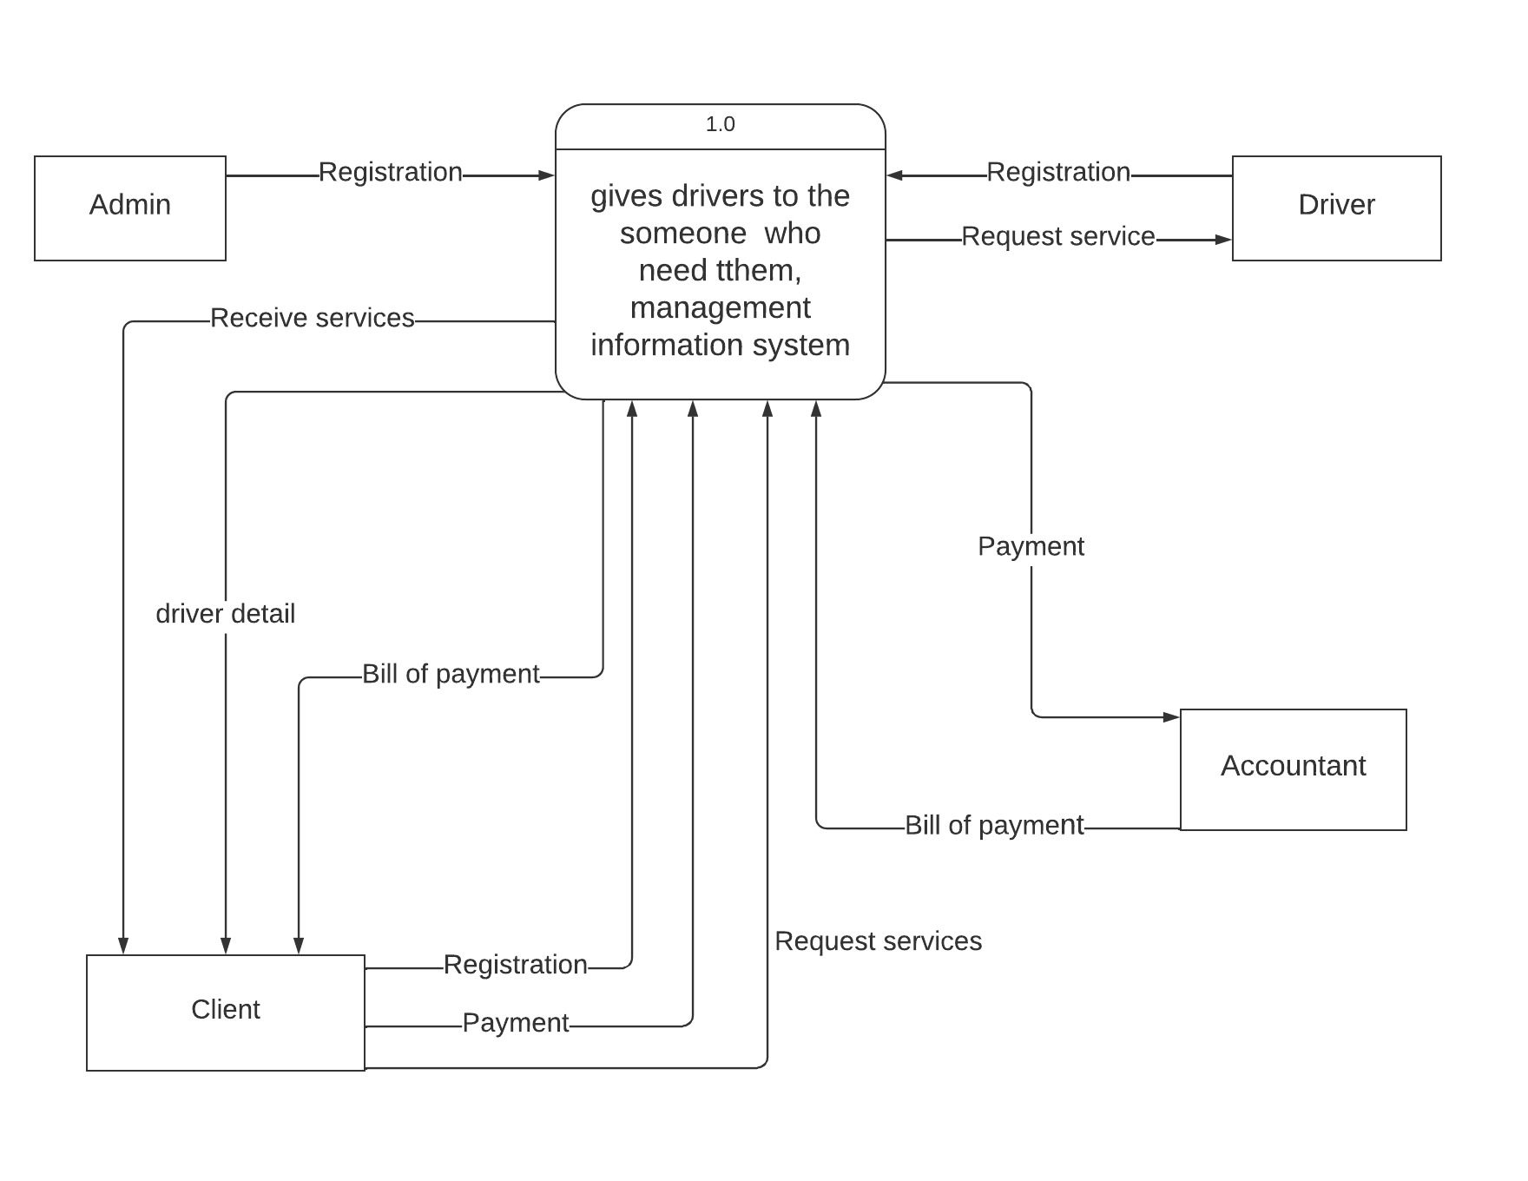

Figure 1. DFD Level 0

This figure defines the boundary between the system, and part of a system, and its environment, showing the entities that interact with it, this diagram is a high-level view of a system.

## 4.2 DFD LEVEL 1

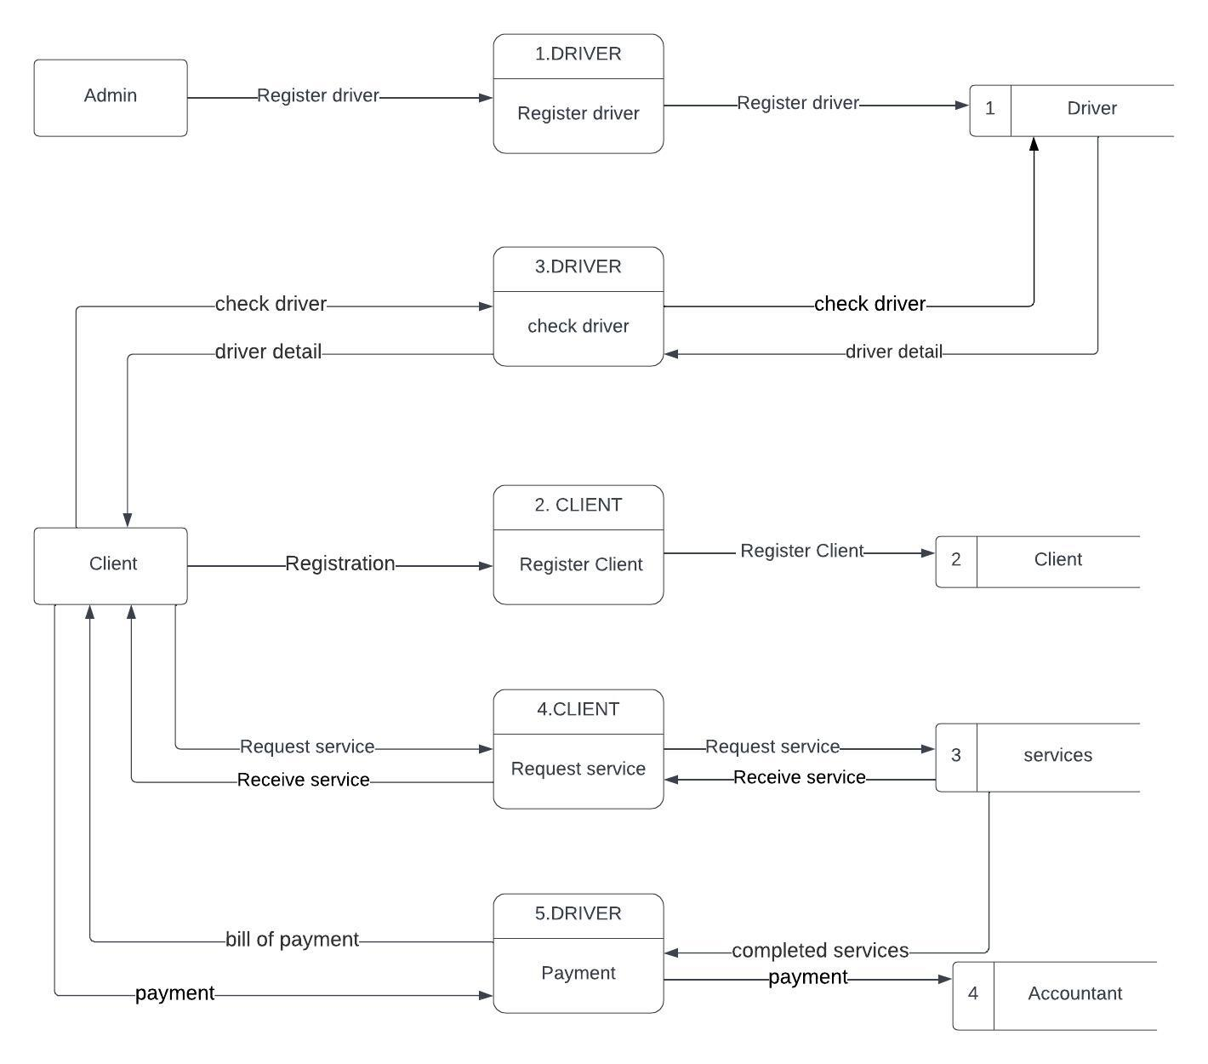

Figure 2. DFD Level 1

This diagram shows the whole system is represented as a single process. A level 1 DFD notates each of the main sub-processes that together form the complete system.

# 5. Feasibility study

5.1 Technical Feasibility

The technical feasibility of advanced driver information system project depends on a number of factors, including the availability of technology, the cost of implementation, and the expertise of the project team.

**The cost of implementing advanced driver information system** **project**: It can vary depending on the size and complexity of the system. However, in general, advanced driver information system projects are relatively cost-effective.

**The regulatory environment**: The system may need to comply with certain regulatory requirements, such as those related to privacy and data protection.

**The size and complexity of the system**: The larger and more complex the system, the more technically challenging it will be to implement.

**The availability of technology**: The project must have access to the necessary technology, such as hardware, software, and networking infrastructure.

**The skills and experience of the team:** The project team must have the necessary skills and experience to develop and implement the system.

**Software Development and Maintenance**: Evaluate the technical capabilities and expertise required for developing and maintaining the advanced driver information system software.

**System Requirements**: Evaluate the system requirements of the advanced driver information system software, including hardware, operating systems, databases, and network infrastructure.

**The scalability of the system:** The system must be able to scale to handle a large number of users and transactions.

**The flexibility of the system:** The system must be flexible enough to adapt to changes in the market or the needs of users.

## 5.2 Financial Feasibility

The financial feasibility of advanced driver information system project depends on a number of factors, including the cost of implementation, the expected benefits, and the availability of funding.

The cost of development and maintenance will vary depending on the specific features and functionality of the system. However, it is important to factor in the cost of hosting the system, as well as the cost of marketing and promoting the system.

**The size and complexity of the system:** The larger and more complex the system, the more expensive it will be to implement.

**The expected benefits**: The greater the expected benefits of the system, the easier it will be to secure funding.

**Return on Investment (ROI):** Calculate the projected ROI by comparing the expected financial benefits (revenue) with the initial and ongoing costs of the project. Determine the payback period the time required for the project to generate sufficient cash flow to recover the initial investment. Evaluate the profitability and long-term sustainability of the project based on the projected ROI.

**Development Costs:** Assess the initial investment required to develop and implement the system, including software development, hardware infrastructure, licensing, and any third-party services or tools needed.

**Operating Costs**: Calculate the ongoing operating costs of running the system, such as server hosting, software updates, maintenance, data storage, user support, and other expenses.

**Breakeven Analysis:** Determine the point at which the revenue generated by the system equals the total costs, resulting in neither a profit nor a loss. This analysis helps determine the time required to recoup the initial investment.

**Funding Sources:** Identify potential funding sources for the development and implementation of the system. This could include internal funding, government grants, or external investments.

**Financial Risk Analysis**: Evaluate potential financial risks that could impact the success of the project, such as changes in market conditions, regulatory changes, or unexpected expenses.

**Scalability:** Consider the scalability of the system and its revenue potential as the user base and services grow over time.

**Cash Flow Analysis**: Analyze the projected cash flow for the system to ensure that there is sufficient cash to cover expenses and maintain operations.

**Payback Period:** Determine the time it takes for the system to generate enough revenue to cover the initial investment.

**Revenue Generation:** Identify potential revenue streams from the system. This may include fees charged for driver services, application fees, transaction charges, or other monetization strategies.

**Cost Savings:** Analyze potential cost savings resulting from increased efficiency and automation of processes within the system. For example, reduced paperwork and manual data entry can lead to savings in administrative costs.

**Market Demand and User Base**: Evaluate the demand for the driver services offered through the system and the potential size of the user base. Understanding the market potential is crucial for estimating revenue generation.

**Pricing Strategy:** Develop a pricing strategy that strikes a balance between attracting customers and generating sufficient revenue. Consider factors such as customer affordability, market competitiveness, and the value proposition of the information system. Conduct pricing sensitivity analysis to evaluate the impact of different pricing scenarios on profitability.

**The regulatory environment:** The system may need to comply with certain regulatory requirements, which may add to the cost of implementation.

The expected number of users will also have a significant impact on the financial feasibility of the project. If the project is expected to attract a large number of users, the potential revenue could be significant. However, if the project is expected to attract a small number of users, the potential revenue may not be enough to cover the cost of development and maintenance.

## 5.3 Market Feasibility

Market feasibility is a measure of how likely a proposed system is to be successful in the marketplace.

The market feasibility of advanced driver information system project depends on a number of factors, including the size and growth of the market, the competition, the target market, and the product's positioning.

**The size of the market:** The size of the market for the system must be large enough to support the project.

**The growth potential of the market:** The market for the system must have the potential to grow in the future.

**The competitive landscape**: The competitive landscape must be favorable for the project. If there are already a number of similar systems in the market, it may be more difficult to attract users and generate revenue.

**The needs of the users:** The system must meet the needs of the users. If the system does not meet the needs of the users, it will not be successful.

**The product's features and benefits**: The product's features and benefits should be clearly communicated to potential customers.

**The product's customer service:** The product should have a good customer service program in place to address any problems that customers may have.

**The price of the product:** The price of the product should be competitive and should be in line with the value that the product offers.

**The willingness of users to pay: Users** must be willing to pay for the system. If users are not willing to pay for the system, it will not be successful.

**The technological environment:** The technological environment must be favorable for the project. If there are new technologies that could disrupt the market, it may be more difficult to be successful.

**The regulatory environment:** The regulatory environment must be favorable for the project. If there are strict regulations governing the collection and use of personal data, it could increase the cost of development and maintenance.

## 5.4 Economic Feasibility

The economic feasibility of advanced driver information system project focuses on assessing whether the project is financially viable and beneficial in the long run. It involves evaluating the costs, benefits, and potential return on investment (ROI) associated with implementing and operating the advanced driver information system.

**Operating Costs**: Consider the ongoing operating costs of running the system, such as hosting and server maintenance, software updates, data storage, and user support.

**Personnel Costs**: Account for the costs of hiring and training personnel to manage and support the system. This includes salaries for administrators, support staff, and technical experts.

**Cost-benefit analysis:** A cost-benefit analysis can be used to compare the costs of implementing advanced driver information system project to the benefits that the system is expected to provide.

**Cost Estimation**: Determine the upfront costs associated with developing and implementing the advanced driver information system.

**Return on investment:** The return on investment (ROI) of advanced driver information system project can be calculated by dividing the benefits of the system by the costs of implementation.

**Funding and Financing:** Evaluate the availability of funding sources for the advanced driver information system project. Determine if the necessary capital can be obtained through government grants, private investments, partnerships, or other funding mechanisms.

**Payback period**: The payback period of advanced driver information system project is the amount of time it takes for the benefits of the system to equal the costs of implementation.

**Integration Costs**: If the system needs to be integrated with existing systems or databases, consider the costs associated with integration efforts.

**Licensing and Compliance Costs:** Factor in any licensing fees or compliance requirements related to data protection, security, and regulatory standards.

**Revenue Generation:** Identify potential revenue streams from the system, such as fees charged for advanced driver system, application fees, or transaction charges.

**Cost Savings:** Analyze potential cost savings resulting from increased efficiency and automation of processes within the system. For example, reduced paperwork and manual data entry can lead to savings in administrative costs.

## 5.5 Legal and Regulatory Feasibility

The legal and regulatory feasibility of advanced driver information system project involves assessing whether the project complies with applicable laws, regulations, and standards.

**Data protection laws:** The project must comply with data protection laws. This means that the project must collect and use personal data in a lawful and transparent manner, and must protect the privacy of users.

**Payment Regulations**: If the system handles payments, ensure compliance with relevant financial regulations and standards for secure and transparent transactions.

**Accessibility Requirements:** Design the system to be accessible to all users, including individuals with disabilities, in compliance with accessibility laws.

**Anti-Discrimination Laws**: Avoid any features or practices within the system that could lead to discrimination against users based on their race, gender, religion, or any other protected characteristics.

**E-commerce laws**: The project must comply with e-commerce laws, such as those governing online payments and sales. This means that the project must ensure that users are protected from fraud and that they are able to make informed decisions about their purchases.

**The applicable laws and regulations**: The project must comply with all applicable laws and regulations, such as those related to privacy, data protection, and access to information.

**Legal Agreements and Contracts: Assess** the need for legal agreements and contracts, such as user agreements, terms of service, privacy policies, and data sharing agreements.

**Transparency**: The project must be transparent about its data collection and use practices. This means that users must be informed about the types of data that is being collected, how it is being used, and how it is being protected.

**The consent of individuals:** The project must obtain the consent of individuals before collecting or using their personal data.

**Accessibility and Discrimination:** Consider accessibility requirements and regulations to ensure that the advanced driver information system project is accessible to all users, including individuals with disabilities.

**Driver Licensing Regulations**: The system should align with local and national driver licensing regulations, ensuring that the issuance, renewal, and revocation of licenses follow the prescribed rules and standards.

**The approval of government agencies:** The project may need to obtain the approval of government agencies.

## 5.6 Operational Feasibility

The operational feasibility of advanced driver information system project refers to the assessment of whether the proposed system can be implemented and integrated into existing operations effectively and efficiently.

**Data Security**: Assess the security measures implemented to protect sensitive data within the system. The data of drivers and users must be safeguarded against unauthorized access and breaches.

**Reliability and Uptime**: Evaluate the system's reliability and availability to ensure it can deliver consistent service without frequent downtime.

**Integration with External Services**: If the system needs to interact with external databases, payment gateways, or other services, assess how well these integrations’ function and whether they are reliable.

**Operational Cost-Benefit Analysis:** Perform a cost-benefit analysis to assess the economic implications of the system's operational requirements. Evaluate the expected benefits and returns against the operational costs.

**The availability of resources:** The project must have access to the necessary resources, such as hardware, software, and personnel.

**User Acceptance:** Assess the willingness of users to adopt and use the advanced driver information system. Conduct surveys, interviews, or focus groups to gather feedback from potential users about their expectations, concerns, and preferences.

**The ability to manage change:** The project team must be able to manage change effectively, as the system will likely evolve over time.

**The skills and experience of the team:** The project team must have the necessary skills and experience to develop and implement the system.

**The complexity of the system:** The system must be complex enough to meet the needs of users, but not so complex that it is difficult to use or maintain.

**Operational Impact**: Analyze how the system will affect day-to-day operations, including transaction times, service quality, and administrative workload. It should streamline processes and improve overall efficiency.

**Change Management**: Plan for change management strategies to address any resistance to change among users and stakeholders. A smooth transition to the new system is essential for successful adoption.

**User Feedback and Continuous Improvement**: Gather feedback from users during testing and implementation phases. Use this feedback to make iterative improvements to the system and enhance its usability and effectiveness.

**The scalability of the system:** The system must be able to scale to handle a large number of users and transactions.

**The flexibility of the system:** The system must be flexible enough to adapt to changes in the market or the needs of users.

**The ability to adapt to new technologies:** The project team must be able to adapt to new technologies as they emerge, in order to keep the system up-to-date.

# Description of the selected Process Model

This system of advanced driver system is used agile model. Agile models are a set of software development methodologies that emphasize iterative and incremental development, frequent delivery of working software, and close collaboration between development teams and stakeholders.

## Cause of your selection

There are several reasons why an agile model might be selected for advanced driver information system project. These are reasons following below:

**Speed:** Advanced driver information systems are often complex and time-sensitive projects. The agile model can help to speed up the development process by breaking down the project into smaller, more manageable tasks

**Flexibility:** Advanced driver information systems are often subject to change. The agile model can help to accommodate these changes by allowing for frequent releases of working software.

**Cost-effective**: The agile model can help to save money by reducing the need for rework and by allowing for more efficient use of resources.

**Risk Management:** Agile methodology emphasizes early identification and mitigation of project risks.

**The need for frequent feedback from users**. Advanced driver information system is typically used by a wide range of users, with different needs and expectations. An agile model allows the project team to get feedback from users early and often, which helps to ensure that the system meets their needs.

**Collaboration**:  The agile model can help to promote collaboration between these stakeholders by encouraging them to work together throughout the development process. This can help to ensure that the system meets the needs of all stakeholders and that it is developed in a timely and efficient manner.

**The need to deliver the system quickly**. In some cases, it is important to deliver advanced driver information system quickly, such as in response to a new government regulation. An agile model can help to shorten the development cycle and deliver the system on time.

**Continuous Improvement:** Agile methodologies promote continuous improvement through retrospective meetings at the end of each sprint.

**Changing Requirements**: Advanced driver information systems often involve complex and evolving requirements. The Agile model allows for flexibility and adaptability in accommodating changes throughout the project.

# Conclusion

In conclusion, advanced driver system project aims to provide efficient and reliable information about advanced drivers and improved customer satisfaction through to give drivers to everyone who need them.

Advanced Driver System Management offers significant benefits and opportunities for improving driver services, enhancing road safety, and streamlining administrative processes. The system provides drivers with real-time information about services available in their area. This information can help drivers to make better decisions and save time and money.

In addition to the benefits for the country, advanced drivers’ information systems can also benefit businesses. The system can be used to promote businesses and attract customers. This information can be used to improve business performance and increase revenue.

The findings of this project suggest that advanced drives systems are a promising technology with the potential to improve transportation efficiency and convenience. However, it is important to continue research on the technology to address the limitations and ensure that it is used safely and effectively.

The advanced driver information system project has been a significant undertaking that has successfully transformed the way drivers interact with their client. The findings of this project suggest that advanced driver management systems have the potential to improve safety, efficiency, and convenience for users. However, there are some limitations to the technology, such as the cost of the system and the potential for driver distraction. Further research is needed to develop more user-friendly interfaces and to evaluate the effectiveness of advanced driver information system in real driving conditions.

Agile methodology is often chosen for transport information system projects due to its flexibility, iterative approach, collaboration, and ability to accommodate changing requirements. Agile enables stakeholders to provide feedback throughout the development process, ensuring that the system meets their evolving needs.

The successful implementation of advanced driver management system project requires careful consideration of various factors, including hardware and software requirements, database management, user interface design, security measures, and integration with other systems. The system has purpose to satisfy the user what they deserve to be served where the user can obtain driver in all part of country.

# References

<https://books.google.rw/books?id=DiVGEAAAQBAJ&printsec=frontcover&source=gbs_ge_summary_r&cad=0#v=onepage>

<https://books.google.rw/books?id=Hwk1EAAAQBAJ&printsec=frontcover&source=gbs_ge_summary_r&cad=0#v=onepage&q&f=false>

<https://ecampusontario.pressbooks.pub/informationsystemscdn/>

<https://books.google.rw/books?id=PBcmnqlqh1IC&printsec=frontcover&source=gbs_ge_summary_r&cad=0#v=onepage&q&f=false>

<https://www.lucidchart.com/pages/examples/diagram-maker>

<https://www.geeksforgeeks.org/dfd-for-library-management-system/>

<https://static1.squarespace.com/static/50c9c50fe4b0a97682fac903/t/512878e6e4b02e5615b4c5ed/1361606886338/Yourdon+DFD.pdf>

<https://www.cybermedian.com/mastering-data-flow-diagrams-a-comprehensive-guide-to-system-analysis-and-design/>

<https://www.cs.uct.ac.za/mit_notes/software/pdfs/Chp06.pdf>

<https://lucid.app/user/185008221#/subscriptionLevel/chart/levelType>

<https://dynamics.microsoft.com/en-us/intelligent-order-management/order-management-system-oms/>

<https://www.adp.com/resources/articles-and-insights/articles/e/employee-management.aspx>

<https://static1.squarespace.com/static/50c9c50fe4b0a97682fac903/t/512878e6e4b02e5615b4c5ed/1361606886338/Yourdon+DFD.pdf>

Party 2: DATABASE MANAGEMENT SYSTEM

Section I

1. Describe all the entities and their corresponding attributes that are in your database.

**Drivers Table:** The Drivers Table can be used to track drivers' availability, assign them to rides, and manage their performance.

Driver_ID (Primary Key)

First_Name,

Last_Name,

Phone_number,

email,

Address,

license_category,

License_Number

**Booking Table**: Booking table: The booking Table can be used to track customer orders, manage customer relationships, and target marketing campaigns through the rate of booking.

Customer_Id Primary Key,

First_Name,

Last_Name,

Location unique key,

Car_Categories,

phone_number,

email

**Orders table:** is a critical part of the system’s database, allowing for efficient storage, retrieval and management of order adata.

Order_id Primary key,

location,

Starting_Point,

Ending_Point,

Estimated_Time,

Order_time,

Order_Date,

**Manager:** this person will get access on all tables but he/she will log in through system development (while programmer is programming the system based on sessions).

**Payments Table:** The Payments Table can be used to track customer payments, manage billing, and generate reports on payment activity.

Payment_id Primary key not null,

payment_code,

amount_perhour,

total_amount,

time,

date

3. Create an LDM of your entities

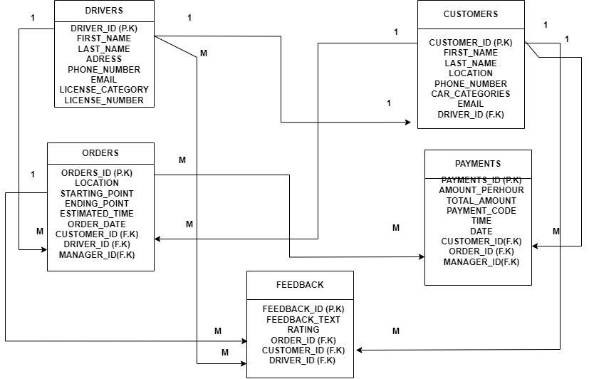

4. Create an ERD

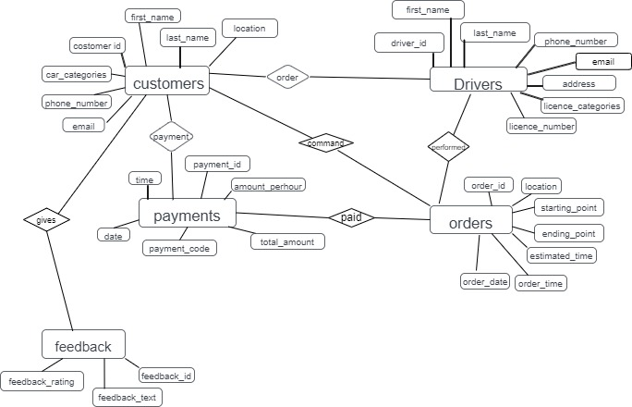

Section II SQL

1. Create the database of your system

**Answer**

Create database

advanced_drivers_management_system;

USE advanced_drivers_management_system;

2. Write queries to create all the tables and relationships of your system

**Answer**

Create table drivers (driver_ID int AUTO_INCREMENT Primary Key NOT NULL, first_Name varchar (50), last_Name varchar (50), phone_number int (10), email varchar (150), address varchar (50), license_category varchar (7) not null, license_Number int (16) not null);

Create table Customers (

Customer_Id INT Primary Key AUTO_INCREMENT NOT NULL,

First_Name varchar (50),

Last_Name varchar (50),

location varchar (50) unique key,

Car_Categories varchar (50),

phone_number varchar (15),

email varchar (100),

driver_id int,

foreign key (driver_id) references drivers(driver_id)

);

Create table Orders (

Order_id INT PRIMARY KEY AUTO_INCREMENT NOT NULL,

customer_id INT NOT NULL,

driver_id INT NOT NULL,

location VARCHAR (100) NOT NULL,

Starting_Point VARCHAR (100),

Ending_Point VARCHAR (100),

Estimated_Time time not null,

Order_time time,

Order_Date date,

FOREIGN KEY (customer_id) REFERENCES customers(customer_id),

FOREIGN KEY (driver_id) REFERENCES drivers(driver_id),

FOREIGN KEY (location) REFERENCES customers(location)

);

CREATE TABLE payments (

payment_id int not null AUTO_INCREMENT,

customer_id int not null,

order_id int not null,

payment_code int not null,

amount_perhour int not null,

total_amount int,

time time,

date date,

PRIMARY KEY (payment_id),

FOREIGN KEY (customer_id) REFERENCES customers (customer_id),

FOREIGN KEY (order_id) REFERENCES orders (order_id)

);

CREATE TABLE registration (

Full_name varchar(500),

email varchar(500),

phone_number PRIMARY_KEY varchar (50)

password varchar(50),

confirm_password varchar(50)

);

3. write queries to insert data into your tables.

**answer**

INSERT INTO Drivers (first_name, last_name, phone_number, Email, Address, license_category, license_number)

insert into drivers values(1,'valatine','mugisha',078845451,'mugisha200@gmail.com','kg122','B',111200);

insert into drivers values(2'bugingo','emmanuel',078845451,'bugingo200@gmail.com','kg122','c',111300);

insert into customers values(002,'jessy','uwase','muhanga','B',078905523,'jessyuwa45@gmail.com',2);

insert into customers values(001,'john','mucyo','kigali','B',078852523,'mucyo11@gmail.com',1);

insert into customers values(003,'jessy','uwase','huye','B',078905523,'jessyuwa45@gmail.com',2);

insert into customers values(004,'joella','keza','kamonyi','B',078907893,'joellakez75@gmail.com',1);

insert into orders values(0001,1,1,'kigali','kg122','kg783',3,'00:30','2023.08.12');

insert into orders values(0002,2,2,'muhanga','muh212','muh143',2,'11:30','2023.08.13');

insert into orders values(0003,3,2,'huye','huy212','huy343',4,'06:30','2023.08.03');

insert into orders values(0004,4,1,'kamonyi','kmy512','kmy143',3,'06:00','2023.06.03');

insert into payments values(0001,1,1,23456,5000,15000,'00:40','2023.08.12');

insert into payments values(0002,2,2,23456,5000,10000,'11:30','2023.08.13');

insert into payments values(0003,3,3,23456,5000,20000,'06:35','2023.08.03’);

insert into payments values(0004,4,4,23456,5000,15000,'06:05','2023.12.03');

insert into feedback values(1,1,1,'seccussful','grade1');

insert into feedback values(2,2,1,'excellent','grade1');

insert into feedback values(3,3,1,'verygood','grade2');

insert into feedback values(4,1,1,'excellent','grade1');

4. Write queries to display all the information in your tables.

**Answer**

SELECT * FROM admin;

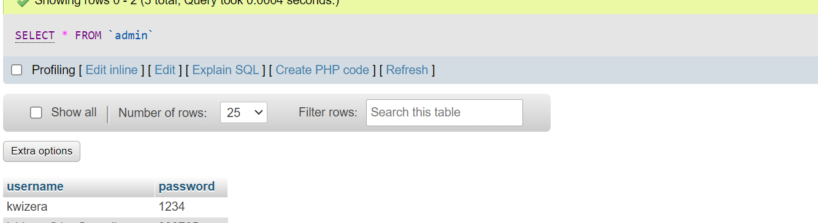

SELECT * FROM Drivers;

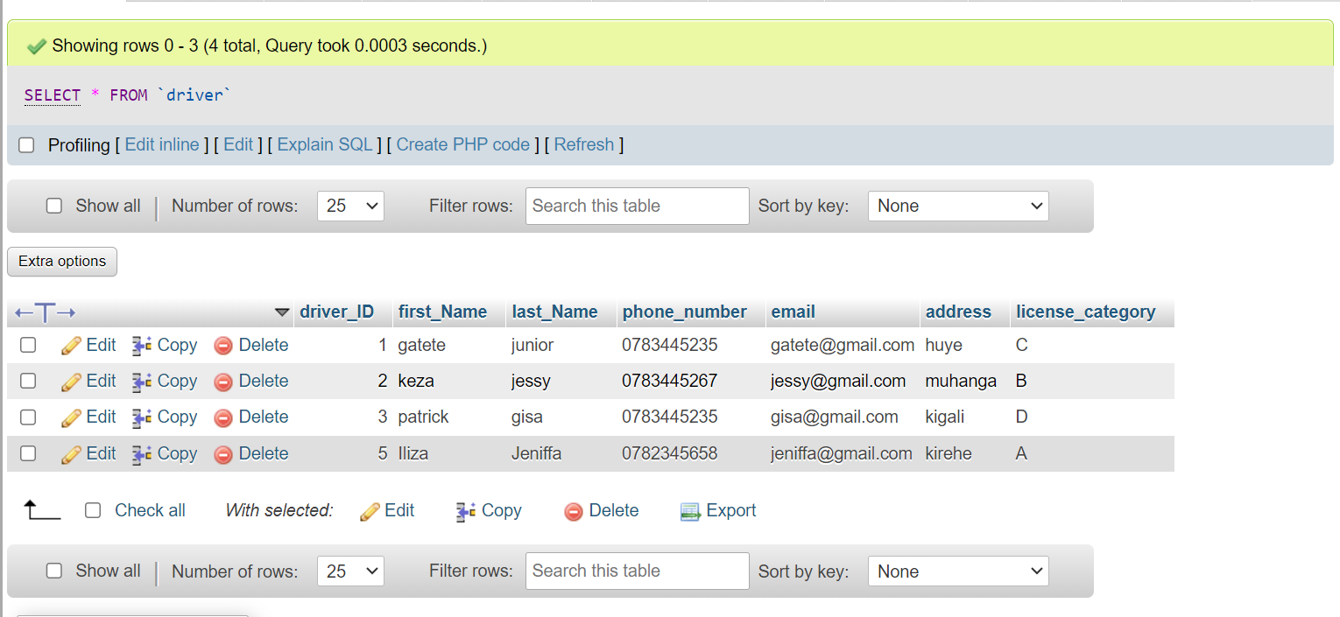

SELECT * FROM registration;

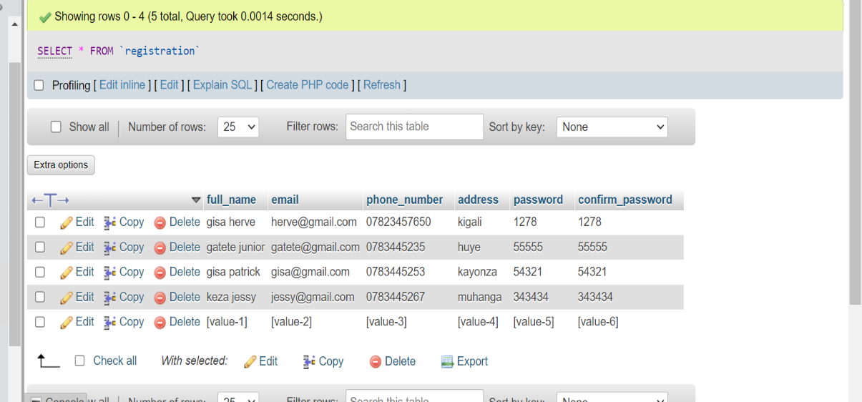

SELECT * FROM booking;

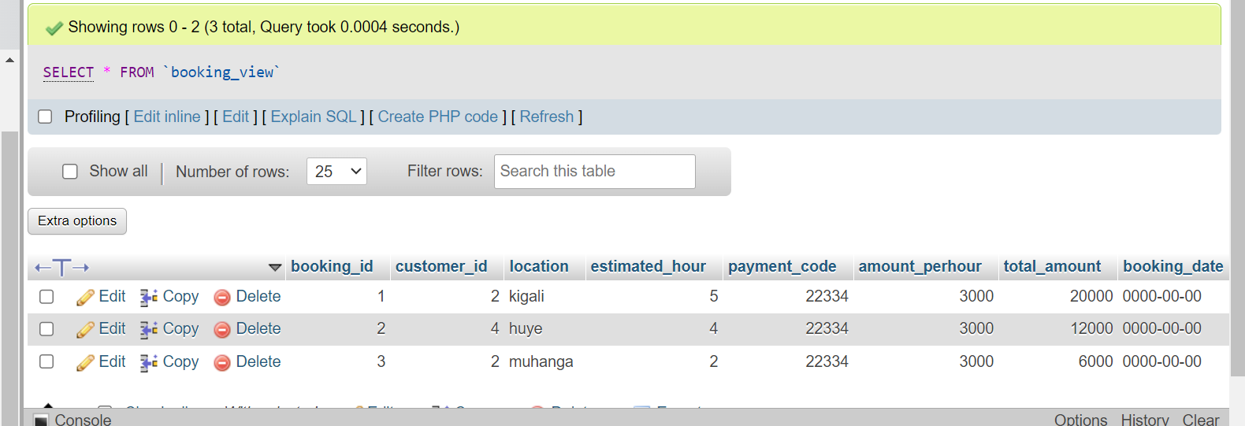

5. Write a query to update information in any of the two tables of your system.

**answer**

update drivers set license_category='B.C.D.d1' where driver_id=2;

update drivers set license_category='B.C.D' where driver_id=1;

update payments set date='2023.06.03' where payment_id=4;

Section III

1. Create a view to insert data into your tables.

**Answer**

Create view driver_view as select * from driver;

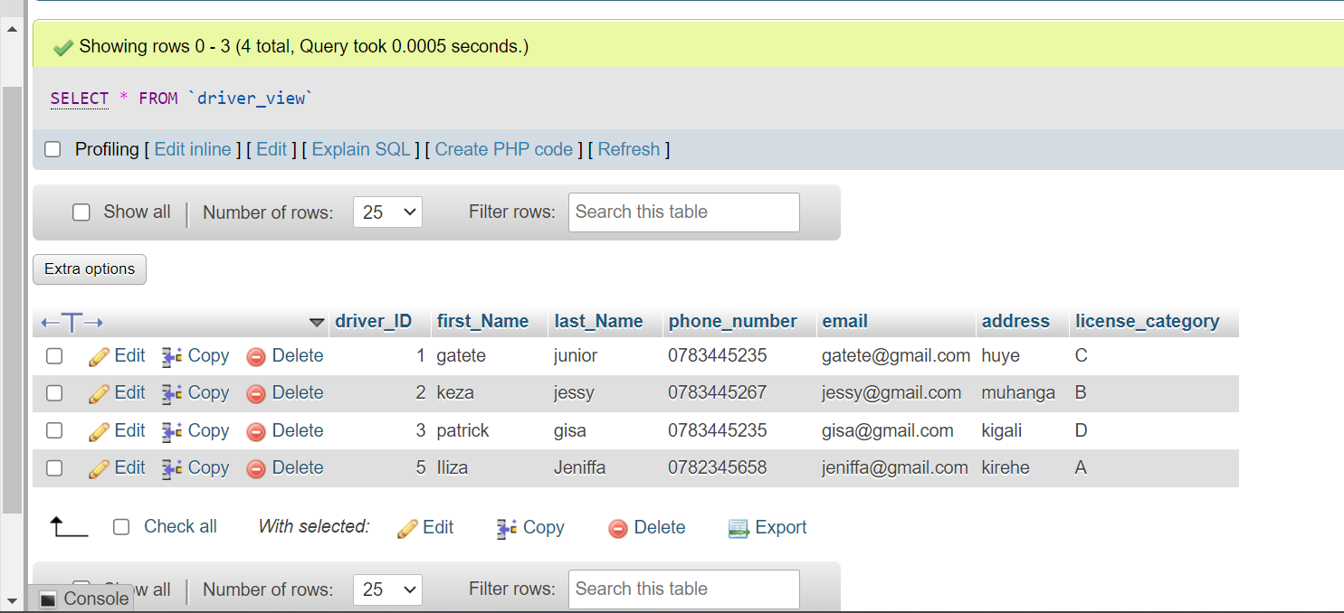

Create view booking_View as select * from booking;

Create view _View_registration as select * from registration;

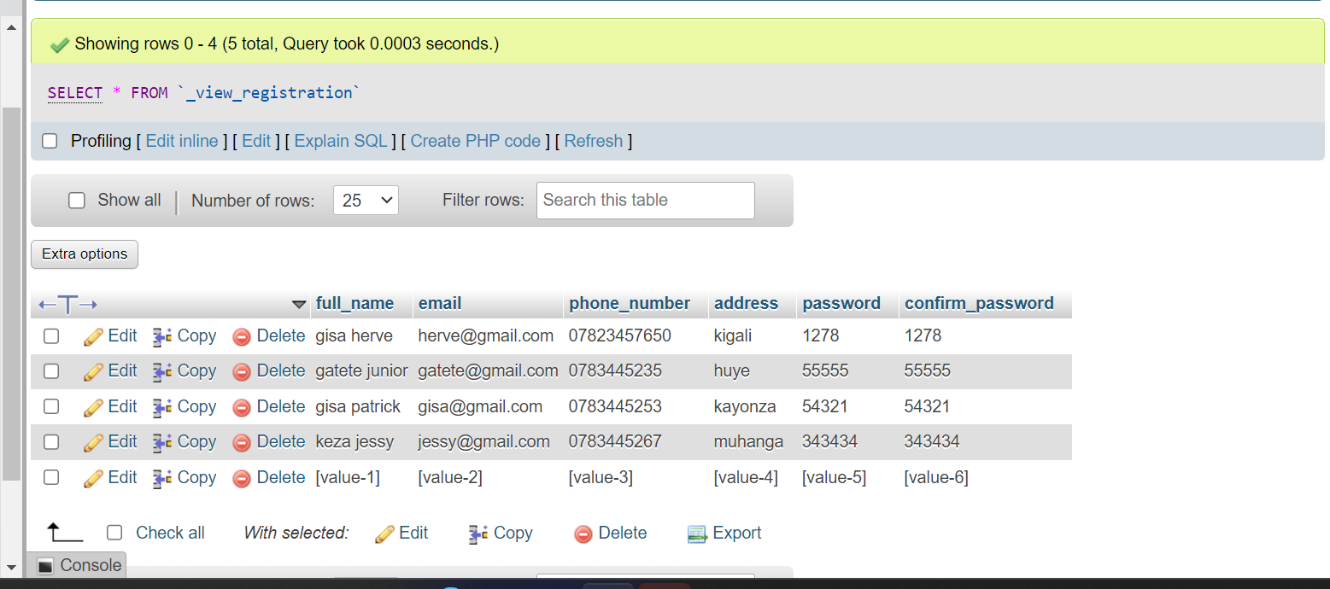

Creating drivers view

CREATE VIEW driver_view AS SELECT driver_id, first_name, address, phone_number,email

FROM drivers

WHERE driver_id =1;

CREATE VIEW customers_view AS SELECT customer_id, first_name, phone_number, email, location

FROM customers

WHERE customer_id =1;

2. Create a view to display all the information in your tables.

**Answer**

Create view driver_booking as select * from driver union all select * from booking;

Select * from driver_view;

Select * from booking_view;

Select * from registration_view;

3. Create a view to update information in any of the two tables of your system.

**Answer**

CREATE OR REPLACE VIEW updatable_drivers_info AS

SELECT driver_id, First_name, Last_name, phone_number, email, address, license_category, license_Number

FROM drivers;

UPDATE **updatable_drivers_info**

SET email=’emmyngabo40@gmail.com'

WHERE driver_id=’02’;

**CREATE OR REPLACE VIEW updatable_customers_info AS**

**SELECT customer_id,** First_Name, Last_Name, location, Car_Categories, phone_number, email

**FROM customers;**

UPDATE **updatable_customers_info**

SET phone_number=’0788449384’

WHERE customer_id=’01’;

4. Create a view to delete data in any two of your tables according to any simple condition of your choice.

**Answer**

**Delete data for view customers_to_delete**

CREATE OR REPLACE VIEW customers_to_delete AS

SELECT*

FROM customers

WHERE customer_id =3;

**Delete data for view orders_to_delete**

CREATE OR REPLACE VIEW orders_to_delete AS

SELECT order_id, location

FROM orders

WHERE order_id=3;

5. In your database, create one view of your choice that considers sub-query.

**answer**

CREATE VIEW check_average_totalamounts_from_payments AS SELECT payment_id,customer_id,order_id,payment_code,amount_perhour,total_amount,time,date FROM payments WHERE total_amount > (SELECT AVG(total_amount) FROM payments);

Section IV

1. Create a stored procedure to insert data into your tables.

DELIMITER //

CREATE PROCEDURE Insertcustomers(

IN p_First_Name VARCHAR(255),

IN p_Last_Name VARCHAR(100),

IN p_location VARCHAR(225),

IN p_Car_Categories VARCHAR(10),

IN p_phone_number VARCHAR(10),

IN p_email VARCHAR(255),

IN p_driver_id INT

)

BEGIN

INSERT INTO customers(First_Name, Last_Name ,location, Car_Categories, phone_number ,email, driver_id)VALUES (p_First_Name,p_Last_Name ,p_location,p_Car_Categories,p_phone_number ,p_email,p_driver_id);

END //

DELIMITER ;

DELIMITER //

CREATE PROCEDURE Insertdrivers(

IN p_First_name varchar(50),

IN p_Last_name varchar(50),

IN p_phone_number INT,

IN p_email varchar(150),

IN p_address varchar(50),

IN p_license_category varchar(7),

IN p_license_Number INT

)

BEGIN

INSERT INTO drivers (First_name, Last_name, phone_number, email, address, license_category, license_Number)

VALUES (p_First_name, p_Last_name, p_phone_number, p_email, p_address, p_license_category, p_license_Number);

END //

DELIMITER ;

DELIMITER //

CREATE PROCEDURE Insertorders(

IN p_customer_id INT,

IN p_location VARCHAR(100),

IN p_Starting_Point VARCHAR (100),

IN p_Estimated_Time time,

IN p_Order_time time,

IN p_Order_Date date

)

BEGIN

INSERT INTO orders (customer_id, driver_id, location, Starting_Point, Ending_Point, Estimated_Time, Order_time, Order_Date) VALUES (p_customer_id, p_driver_id, p_locationl, p_starting_point, p_Ending_Point, p_Estimated_Time, p_Order_time, p_Order_time);

END //

DELIMITER ;

DELIMITER //

CREATE PROCEDURE Insertpayments(

IN p_customer_id int,

IN p_order_id int,

IN p_payment_code int,

IN p_amount_perhour int,

IN p_total_amount int,

IN p_time time,

IN p_date date

)

BEGIN

INSERT INTO payments (customer_id,order_id,payment_code,amount_perhour,total_amount,time, date) VALUES (p_customer_id,p_order_id,p_payment_code,p_amount_perhour,p_total_amount, p_time,p_date);

END//

DELIMITER;

1. Create a stored procedure to display all the information in your tables.

DELIMITER //

CREATE PROCEDURE DisplaydriversData()

BEGIN

SET @sql = 'SELECT * FROM drivers';

PREPARE stmt FROM @sql;

EXECUTE stmt;

DEALLOCATE PREPARE stmt;

END //

DELIMITER ;

CALL DisplaydriversData();

DELIMITER //

CREATE PROCEDURE DisplaycustomersData()

BEGIN

SELECT * FROM customers;

END //

DELIMITER ;

CALL DisplaycustomersData();

DELIMITER //

CREATE PROCEDURE DisplayordersData()

BEGIN

SELECT * FROM orders;

END //

DELIMITER ;

CALL DisplayordersData();

DELIMITER //

CREATE PROCEDURE DisplaypaymentsData()

BEGIN

SELECT * FROM payments;

END //

DELIMITER ;

CALL DisplaypaymentsData();

3. Create a stored procedure to update information in any of the two tables of your

system.

DELIMITER //

CREATE PROCEDURE Updatedrivers(

IN p_driver_ID INT,

IN p_newphone_number VARCHAR(200)

)

BEGIN

UPDATE drivers

SET phone_number = p_newphone_number

WHERE driver_ID = p_driver_ID;

END //

DELIMITER ;

CALL Updatedrivers(1, '0786455373');

DELIMITER //

CREATE PROCEDURE Updatepaymentsrecord(

IN p_payment_id INT,

IN p_Newamount_perhour VARCHAR(10)

)

BEGIN

UPDATE payments

SET amount_perhour = p_Newamount_perhour

WHERE payment_id = p_payment_id;

END //

DELIMITER ;

CALL Updatepaymentsrecord(1, '20000');

4. Create a stored procedure to delete data in any two of your tables according to any

simple condition of your choice.

**answer**

DELIMITER //

CREATE PROCEDURE Deletedriverbyfirstname(

IN p_first_Name VARCHAR(255)

)

BEGIN

DELETE FROM drivers

WHERE first_Name =p_first_Name;

END //

DELIMITER ;

CALL Deletedriverbyfirstname ('bugingo');

DELIMITER //

CREATE PROCEDURE DeletefrompaymentsBypaymentid(

IN p_payment_id INT

)

BEGIN

DELETE FROM payments

WHERE payment_id = p_payment_id;

END //

DELIMITER ;

CALL DeletefrompaymentsBypaymentid('1');

5. In your database, stored the procedure view of your choice that considers subquery.

**answer**

DELIMITER //

CREATE PROCEDURE CreatepaymentsAverageView()

BEGIN

SET @sql = '

CREATE OR REPLACE VIEW paymentsAverageView AS

SELECT w.payment_id,w.customer_id,w.order_id,w.payment_code,w.amount_perhour, w.total_amount,w.time,w.date

FROM payments w

WHERE w.total_amount> (

SELECT AVG(s.total_amount)

FROM payments s

WHERE s.payment_id = w.payment_id

);

';

PREPARE stmt FROM @sql;

EXECUTE stmt;

DEALLOCATE PREPARE stmt;

END //

DELIMITER ;

**SECTION V**

1. Create after inserting triggers for any two tables of your choice.

**answer**

DELIMITER //

CREATE TRIGGER AfterInsertdrivers

AFTER INSERT ON drivers

FOR EACH ROW

BEGIN

INSERT INTO drivers_audit (driver_id, action, action_date)

VALUES (NEW.driver_id, 'INSERT', NOW());

END //

DELIMITER ;

DELIMITER //

CREATE TRIGGER AfterInsertcustomers

AFTER INSERT ON customers

FOR EACH ROW

BEGIN

INSERT INTO customers_audit (customer_id, commandimg, commanding_date)

VALUES (NEW.customer_id, 'INSERT', NOW());

END //

DELIMITER ;

1. Create after-update triggers for any two tables of your choice.

**answer**

DELIMITER //

CREATE TRIGGER AfterUpdatedrivers

AFTER UPDATE ON drivers

FOR EACH ROW

BEGIN

INSERT INTO drivers_audit (driver_id, action, action_date)

VALUES (NEW.driver_id, 'UPDATE', NOW());

END //

DELIMITER ;

DELIMITER //

CREATE TRIGGER AfterUpdatecustomers

AFTER UPDATE ON customers

FOR EACH ROW

BEGIN

INSERT INTO customers_audit (customer_id, commanding, commanding_date)

VALUES (NEW.customer_id, 'UPDATE', NOW());

END //

DELIMITER ;

1. Create after deleting triggers for any two tables of your choice.

**Answer**

DELIMITER //

CREATE TRIGGER payments

AFTER DELETE ON payments

FOR EACH ROW

BEGIN

INSERT INTO orders (payment_id, action, action_date)

VALUES (payment_id, 'DELETE', NOW());

END //

DELIMITER ;

DELIMITER //

CREATE TRIGGER AfterDeletepayments

AFTER DELETE ON payments

FOR EACH ROW

BEGIN

UPDATE club SET total_amount = total_amount - 1 WHERE payment_id = payment_id;

END //

DELIMITER ;

Section VI

1. Create a user with your name as username and your student number as password

and grant all privileges to the created user.

**answer**

mysql -u root -p

create user 'valentinkwizer'@'localhost'IDENTIFIED BY '222007317';

GRANT ALL PRIVILEGES ON *.* TO 'valentinkwizer'@'localhost';

FLUSH PRIVILEGES;

exit;

2. Create a user with your "names_semi" as username and your student number as

password and give him insert, update, and delete privileges to the created user.

**answer**

mysql -u root -p

CREATE USER 'kwizera'@'localhost' IDENTIFIED BY '222007317';

GRANT INSERT, UPDATE, DELETE ON *.* TO 'kwizera'@'localhost';

FLUSH PRIVILEGES;

exit;

3. Revoke insert privileges to the last user you created.

**answer**

mysql -u root -p

REVOKE INSERT ON *.* FROM 'kwizera'@'localhost';

FLUSH PRIVILEGES;

exit;

Party 3: **JAVA PROGRAMMING**

INTRODUCTION

Welcome to our advanced driver management system, where seamless user interaction begins with our intuitive login and registration forms. Users can effortlessly choose their role as admin or customer and access our platform's extensive features with ease. Admins enjoy complete system control, from registering drivers to managing database entries efficiently. Meanwhile, customers experience streamlined booking processes, allowing them to reserve drivers and update their details effortlessly. Explore our user-friendly interface designed to enhance your experience and streamline your operations.

**Tools used to develop this system in java programming.**

Eclipse IDE, a versatile integrated development environment, facilitates computer programming with its customizable features. Featuring a base workspace and an extensible plug-in system, it offers developers a tailored environment for coding projects. Renowned as the second-most-popular IDE for Java development, Eclipse held the top spot until 2017, highlighting its enduring significance in the programming landscape.

**JDK** stands for **Java Archive.** It's a file format based on the popular ZIP file format and is used for aggregating many files into one. Although JDK can be used as a general archiving tool, the primary motivation for its development was so that Java applets and their requisite components.

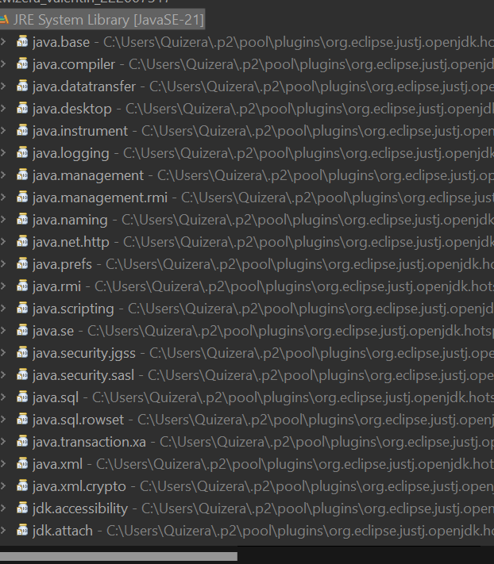

MySQL Connectors. MySQL provides standards-based drivers for JDBC, ODBC, and .Net enabling developers to build database applications in their language.

Here we are going to show the system function step by step from the beginning up to the end.

1. **LOGIN FORM**

The login form allows users to select their role as admin or customer, providing fields for email and password entry. Upon clicking the **login button**, users gain access to the system. In the absence of an account, users can utilize the **reset button** to potentially clear input fields or initiate the registration process.

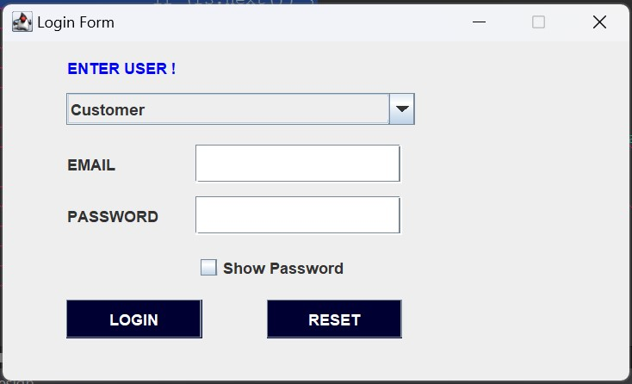

1. **REGISTRATION FORM**

The registration form streamlines user enrollment by enabling them to input necessary details and finalize registration with the "Sign Up" button. Upon system entry, users are guided to this form as the first step in the onboarding process. Upon successful registration approval, users are redirected back to the login form, marking the completion of their enrollment journey.

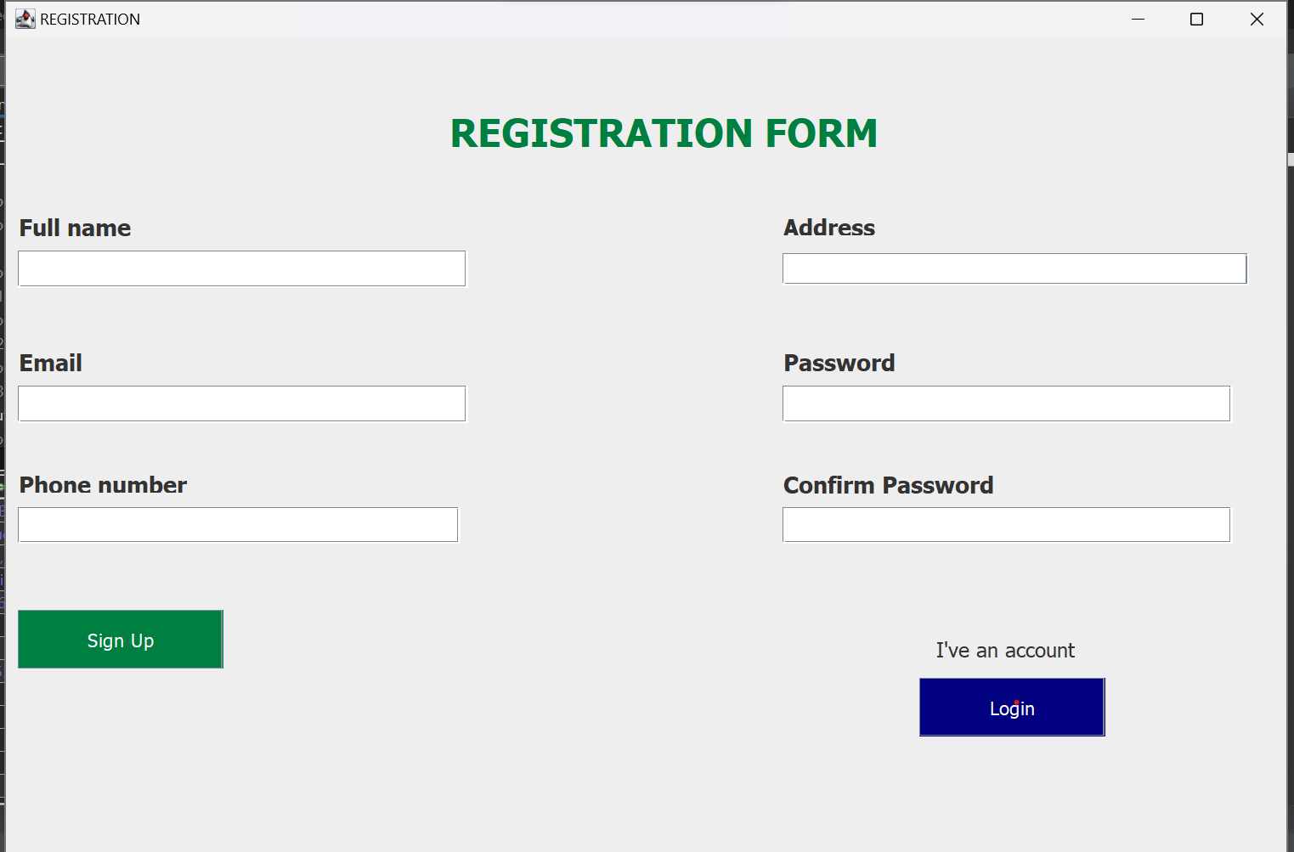

1. **WHEN YOU CHOOSE ADMIN**

Upon choosing the admin option, users proceed to input their email and password into the designated fields. Subsequently, users can successfully log in by pressing the login button, granting them access to the system's administrative features.

Following admin login, complete system control is granted, allowing for driver registration and comprehensive management. This authority enables seamless oversight and optimization of system operations, ensuring efficient functionality.

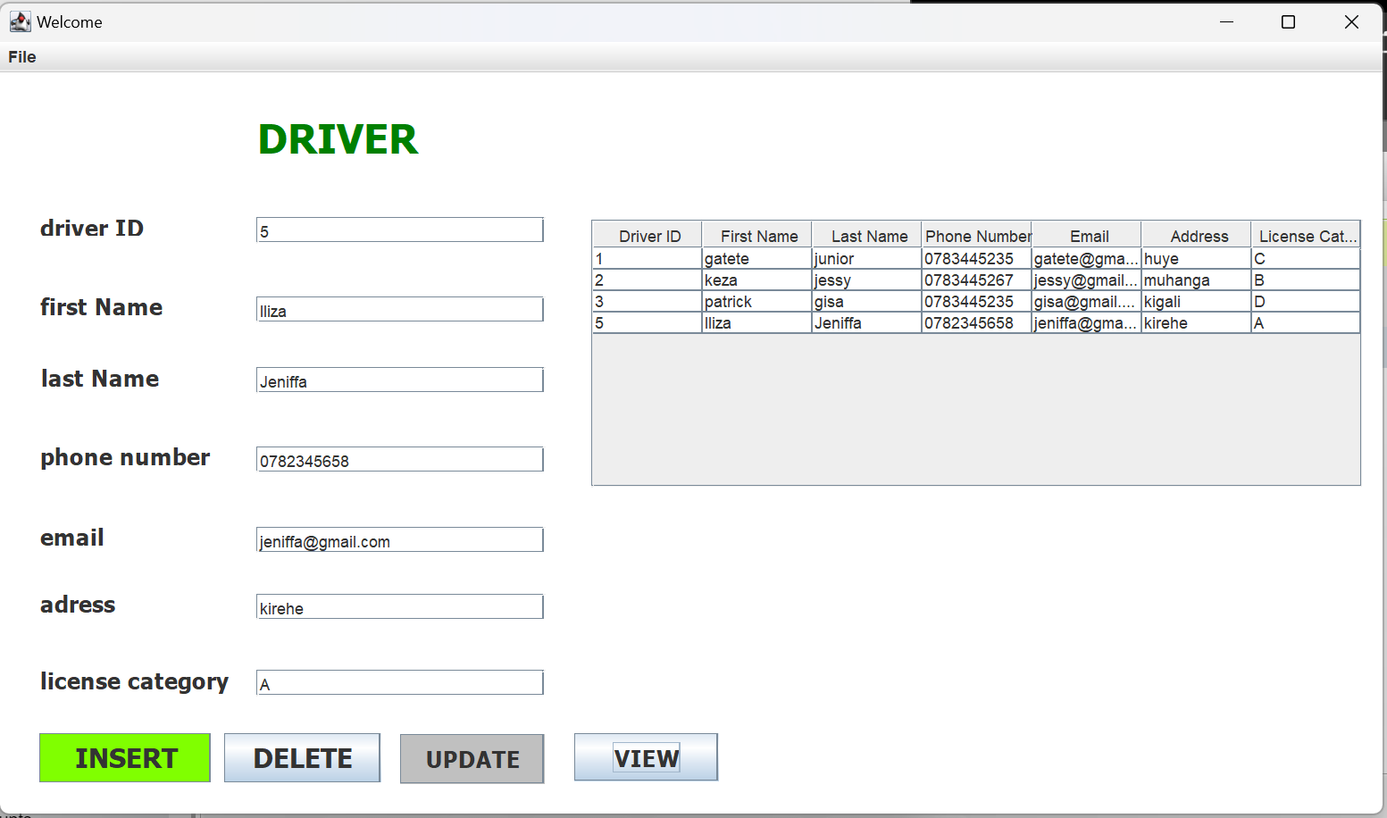

On the "**Insert" button,** the administrator can seamlessly incorporate new driver data into the database. This functionality streamlines the process of onboarding drivers, ensuring that their information is promptly integrated into the system upon submission.

With the "**Delete" button**, the administrator is granted the privilege to remove any outdated or redundant data entries from the database. This capability allows the administrator to maintain data hygiene by swiftly eliminating irrelevant records or correcting errors within the system.

The "**Update**" functionality empowers the admin to enact modifications to existing data entries within the database. Whether it involves rectifying inaccuracies, updating contact information, or incorporating recent changes, the admin can seamlessly implement alterations to ensure that the database reflects the most current and accurate information.

Through the "**View" button,** the admin gains comprehensive access to the entirety of the database's contents. This feature enables the admin to effortlessly survey and analyze all available data within the system. By providing a comprehensive overview of the database's information, the "View" functionality facilitates informed decision-making and meticulous oversight of the system's operations.

1. **WHEN YOU CHOOSE CUSTOMER**

In this customer login form, users must first select their role from the menu sign before proceeding. Once chosen, users input their email and password into the designated text fields. Upon completing the fields, users click the login button to gain access to the system's functionalities.

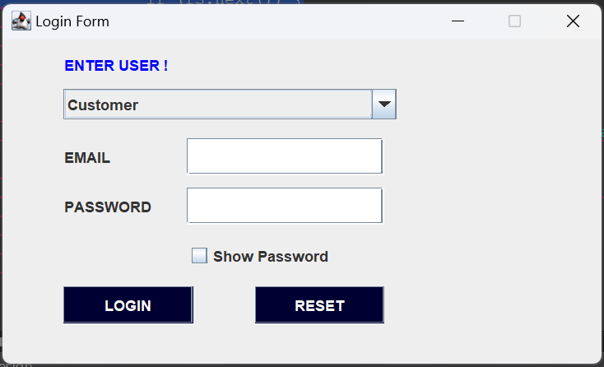

Upon logging in, customers can access a comprehensive booking form to input their details. This form enables customers to reserve a dedicated driver who will provide transportation services at the scheduled time.

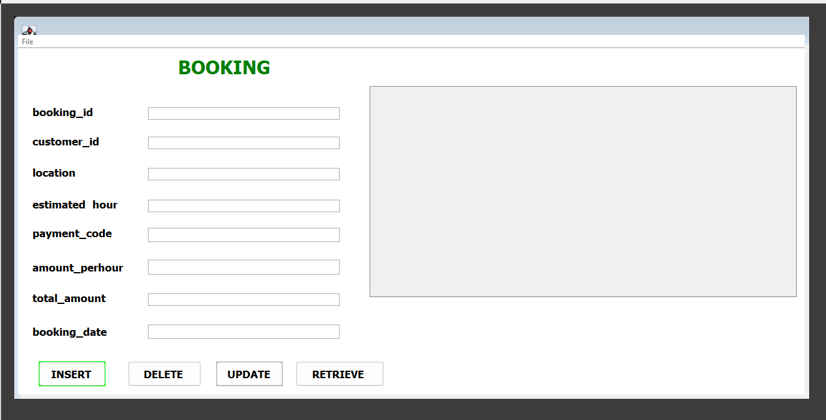

Customers can initiate the booking process by clicking on the "**Insert" button** after completing the booking form. This action enables customers to submit their booking details, facilitating the seamless addition of their reservation into the system.

The "**Delete" button** empowers admin to remove specific booking orders or details from the system when necessary. This functionality enables admin to maintain database cleanliness by swiftly eliminating outdated or redundant booking entries.

Through the **"Update" button**, customers gain access to their booking form, allowing them to modify or update their booking information as needed. This functionality enables customers to make adjustments to their reservation details, such as changing dates, updating contact information, or modifying booking preferences. By providing customers with the flexibility to manage their bookings, the system enhances user autonomy and satisfaction.

Customers can utilize the "**Retrieve" button** to access comprehensive information regarding their booking by entering the booking ID and initiating the retrieval process. This feature enables customers to view detailed information about their reservation, including booking status, itinerary details, and payment information.

**CONCLUSION**

As conclusion, This Java project presents an advanced drivers management system with intuitive login and registration forms. Users can choose roles as admin or customer, accessing features seamlessly. Admins manage driver registration and database entries efficiently, while customers experience streamlined booking processes. Developed using Eclipse IDE and MySQL Connectors, the system offers comprehensive functionalities for user autonomy and satisfaction, with room for improvement guided by external feedback.

**REFERENCES:**

1. Eclipse IDE: [https://www.eclipse.org/ide/](https://www.eclipse.org/ide/)

2. Java Programming Language: [https://www.oracle.com/java/](https://www.oracle.com/java/)

3. JavaFX for User Interface Development: [https://openjfx.io/](https://openjfx.io/)

4. MySQL Database: [https://www.mysql.com/](https://www.mysql.com/)

5. Hibernate ORM Framework: [https://hibernate.org/](https://hibernate.org/)

6. Google Maps API for Location Services: [https://developers.google.com/maps](https://developers.google.com/maps)